Distance.

A distance measure is an objective score that summarizes the relative difference between two objects in a problem domain.

Chevishef. Minkovski

Confusion matrix.

Performance measurement for machine learning classification problem where output can be two or more classes. It is a table with 4 different combinations of predicted and actual values.

Actual Values; True or False

Predicted values; Positive or Negative

What you predict (P,N) (in that order as rows), is either (T,F) (true values appear in the diagonal)

True Positive; Predicted a woman is pregnant and she actually is.

True Negative; Predicted a man is not pregnant and he actually isn’t.

False Positive, I error; Predicted a man is pregnant and that is false.

False Negative, II error; Predicted a woman is not pregnant and that’s false she is.

**Accuracy.**

Number of correct predictions divided by the total number of predictions, multiplied by 100. Diagonal by total.

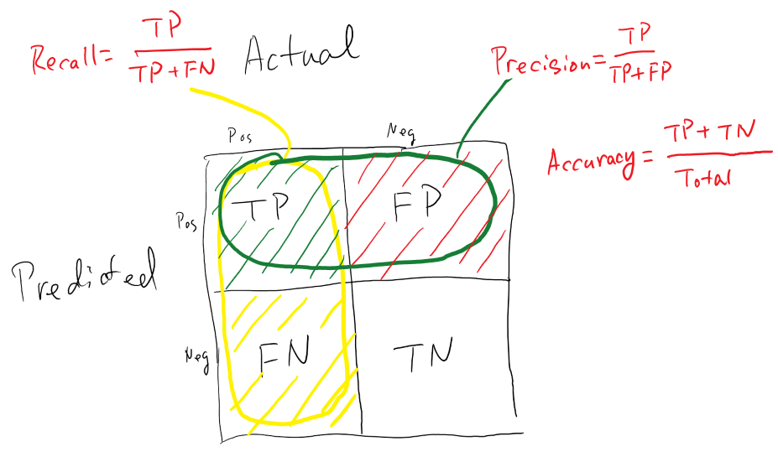

**Sensitivity/Recall. Proportion of true positives that are correctly predicted.**

Ratio of true positives to all the positives in ground truth. Focus on type II errors. First column. 1 means model didn’t miss any true positives and is able to classify well between correctly and incorrectly labeling of pregnant people.

**Specificity. Proportion of true negatives that are correctly predicted.**

Ratio of true negatives to all the negatives in ground falseness. Focus on type I errors. Second column. 1 means model didn’t miss any true negatives and is able to classify well between correctly and incorrectly labeling of no pregnant people.

**Validation.**

process of deciding whether the numerical results quantifying hypothesized relationships between variables, are acceptable as descriptions of the data.

You need some kind of assurance that your model has got most of the patterns from the data correct, and its not picking up too much on the noise, or in other words its low on bias and variance.

You first do an error estimation from training data. This could be misleading and be overfitting or underfitting. Cross validation indicates how well the model will generalize to an independent/unseen (test) data set.

K-Fold Cross Validation.

every data point gets to be in a validation set exactly once, and gets to be in a training set k-1 times. This significantly reduces bias as we are using most of the data for fitting, and also significantly reduces variance as most of the data is also being used in validation set. Interchanging the training and test sets also adds to the effectiveness of this method.

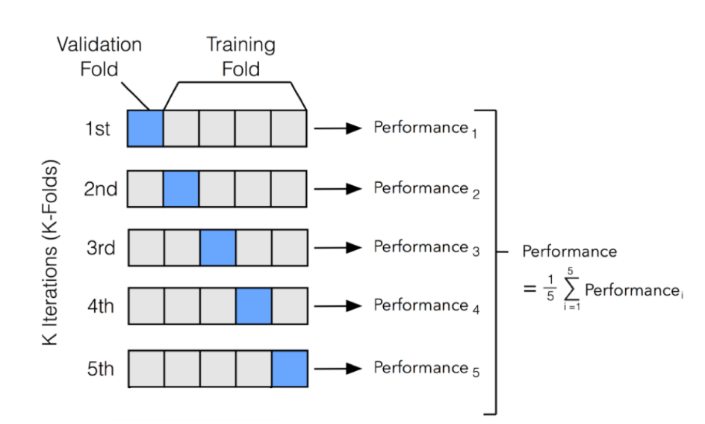

Redes neuronales

El modelo de aprendizaje es una regla de corrección basada en el error. Aprende cuando sus pesos pueden resolver con un mínimo de error las distancias con la que fue entrenado (pesos convergen). Dropout es le corte de conexiones en la arquitectura para caracterizar la diferencia de rendimiento de la red. La taza de aprendizaje es un hiperparámetro (la variable libre de penalización) taza de aprendizaje inicial es alta por que hay mucha variabilidad. Talle u objetivo y la es el valor de salida de la red. La actualización de peso por característica es la medida del error por la cantidad de aprendizaje que necesita

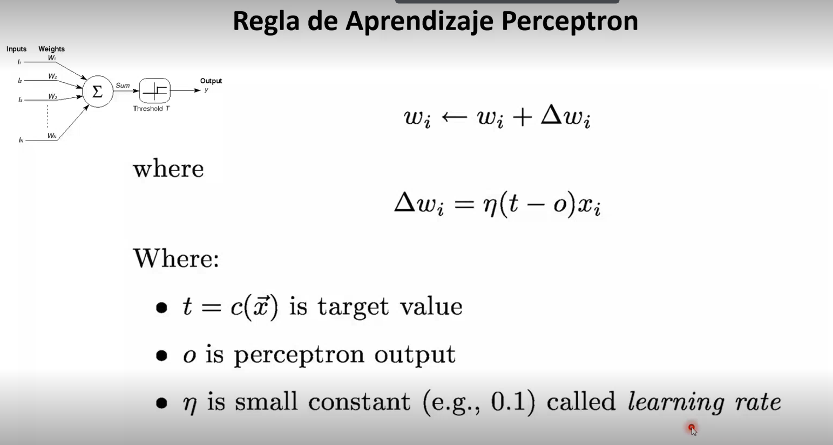

La función de activación filtra los valores menores a un valor, particularmente 0. B es el Prejuicio. Si taza de aprendizaje alta, se tiene penalización alta y el ajuste es grande.

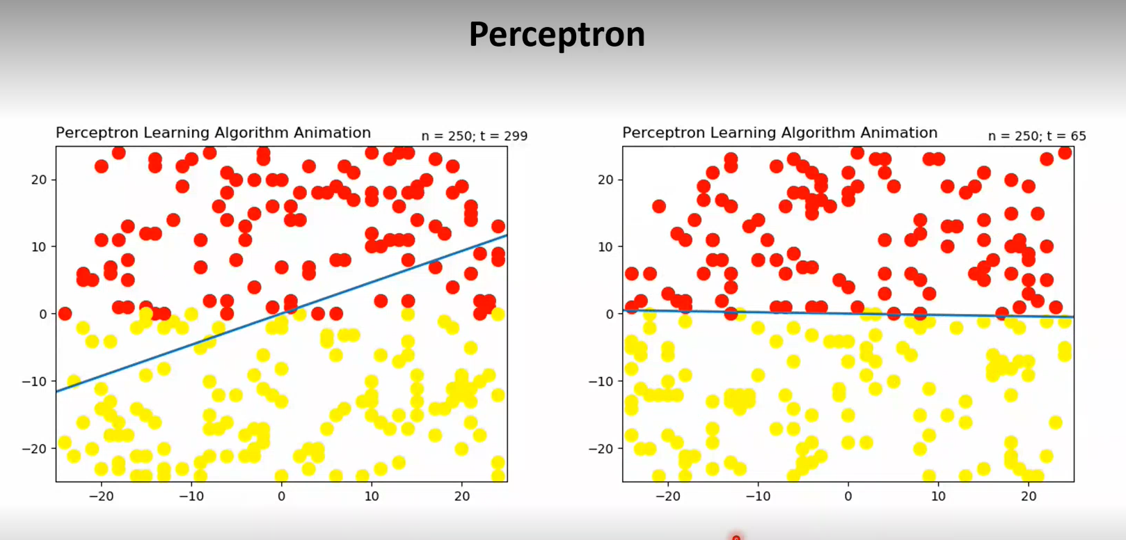

Inestabilidad por cada ejemplo por la falta de función de optimización, por lo tanto posible mal rendimiento para algún t.

Las funciones de decisión son equivalentes al hiperplano de SVM, y a tener todas las distancias posibles entre los distintos puntos en knn.

Isomorfismo. Si hay un algoritmo que te puede resolver el coloreo de mapas, también puede resolver el problema de la satisfacción. Hay internamente cosas en común.